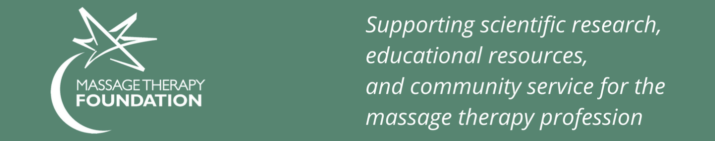
Dear Chapter Colleagues,
Welcome to Massage Therapy Foundation’s Chapter Resource Center.
Thank you for being our champions and supporting the Foundation’s efforts. We have organized materials for you to more easily spread our message and help us fundraise.
The Chapter Resource Center contains video links, donation forms, research tools, infographics, printable flyers, prewritten social media posts, etc. Our hope is to make it easy for you to introduce us to your members so that they can discover who we are and how the MTF can benefit them and their clients.
Choose to use any portion of the kit material you deem appropriate. Please include content in your annual meetings, on your social media, and during year-round events. Individual members can also easily customize the materials to connect with colleagues and clients.
If you have any questions, please contact Marla Gamze, Massage Therapy Foundation’s Development & Communications Manager at 847-905-1635 or at mgamze@MassageTherapyFoundation.org.
Thank you so much for your volunteer time in support of the Foundation. Our MTF staff, board members, volunteers, and grant recipients appreciate you!
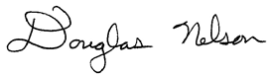
With sincere gratitude,

Doug Nelson, LMT, BCTMB, CNMT
Massage Therapy Foundation President

