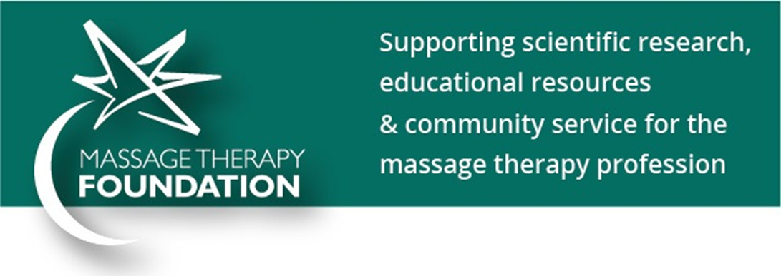
Massage Therapy Foundation Key Message Points
Research:
- Research Grants that investigate the benefits of massage therapy in areas like chronic pain, muscle injuries, and cancer recovery.
- International Massage Therapy Research Conference (IMTRC) that educates practitioners about the research process and provide an opportunity to disseminate current massage research.
- International Journal of Therapeutic Massage & Bodywork: Research, Education, & Practice (IJTMB). A free, on-line peer-reviewed publication covering research, education and practice. Subscribe at www.ijtmb.org.
- Research Perch podcast series designed to help you learn how to use massage therapy research in your practice, and exploring articles from ITJMB, as well as other past and present research.
- Research articles that allow readers to explore the science behind massage therapy.
Community Service:
- Community Service Grants that deliver massage to underserved populations all over the world.
- Case Report Webinar Series which highlights case report essentials and writing processes, making it easy for you to write your own case report.
Education:
- E-Newletters that inform you about current industry research, events and opportunities.
- Education that teaches skills to locate, interpret, evaluate, and apply research findings for the benefit of clients.
- Massage Therapy Foundation free eBooks that offer resources for use in education, research, teaching and learning.
- Student Case Report contest that enhance professional development and research skills.
- Research literacy courses
- Poster/abstract submissions
- Student and teacher research tools
- Educational blog posts

www.massagetherapyfoundation.org

