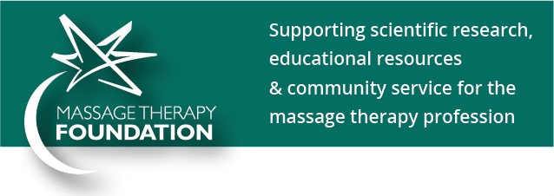
Research Tools and Resources
Webinars
Importance of Research Literacy with Ruth Werner and Dr. Leena Guptha
Basics of Research Literacy
Finding and Evaluating Research
Research Article Databases
- Biomed Central
- MerckMedicus
- PubMed
Government Agencies funding Complementary and Alternative Medicine Research
- National Center for Complementary and Alternative Medicine
- White House Commission on Complementary & Alternative Medicine Policy (WHCCAMP)
Organizations
- American Massage Therapy Association (AMTA)
- Canadian Interdisciplinary Network for Complementary and Alternative Medicine Research (IN-CAM)
- Commission on Massage Therapy Accreditation (COMTA)
- Consortium of Academic Health Centers for Integrative Medicine
- Fascia Research Congress
- International Spa Association
- National Certification Board for Therapeutic Massage & Bodywork (NCBTMB)
- Orthopedic Massage Education & Research Institute (OMERI)
- Registered Massage Therapists’ Association of British Columbia
- Society for Integrative Oncology
- Touch Research Institute
Publications
- Alternative Therapies in Health and Medicine
- Integrative Medicine, A Clinicians Journal (IMCJ)
- International Journal of Therapeutic Massage & Bodywork: Research, Education, & Practice (IJTMB)
- Journal of Bodywork & Movement Therapies
- Massage and Bodywork Magazine
- Massage Magazine
- Manual Therapy
- Massage Therapy Canada
- Massage Therapy Journal (MTJ)
- Massage Today
Research Columns & Newsletters
- MTF Research Articles on MassageToday.com – As part of our continuing goal to promote research literacy and capacity in the massage profession, we publish a monthly research project synopsis, with a reference to the original article, on MassageToday.com. These synopses are authored by volunteers from our Writing Workgroup.
- Somatic Research Column – Massage & Bodywork Magazine
- To Your Health newsletter from Massage Today
Links to Research and Professional Resources
- Glossary of Research Terms (an excerpt from G. Hymel: Research Methods for Massage and Holistic Therapies, ISBN 0-323-03292-3)
- Methodological Issues in Investigations of Massage/Bodywork Therapy – Claire M. Cassidy, PhD
- The Integrator Blog
- Association of Massage Therapists Classified Massage Therapy Research Update, January 2015
Research Literature Syntheses
The MTF has commissioned the writing of two literature syntheses that have been published; one on massage for stress and the other on sports massage. Each is a comprehensive review of the literature on their respective subject areas and should be helpful to those seeking research on these specific topic areas.
Massage and Stress Reduction
- Moraska, A, Pollini, R, Boulanger, K, Brooks, M. Z., Teitlebaum, L. (2010) “Physiological Adjustments to Stress Measures Following Massage Therapy: A Review of the Literature”. Evidence-Based Complementary and Alternative Medicine: 7(4) doi:10.1093/ecam/nen029
Sports Massage
- Moraska, Albert (2005) “Sports Massage: A Comprehensive Review.” The Journal of Sports Medicine and Physical Fitness: 45(3).

www.massagetherapyfoundation.org

