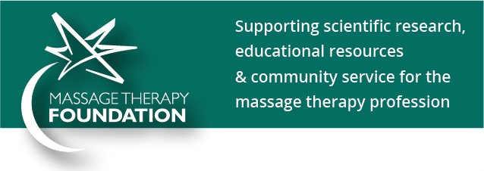
Massage Therapy Foundation – Pre-written Blogs
Research Grant Blog:

Every year, the Massage Therapy Foundation funds research grants which advance the state of massage therapy science. The generosity of MTF’s donors enables them to award funds for high-quality, independent research studies that enhance the understanding of therapeutic massage applications and their roles in health-care delivery. The Foundation’s recent research has funded studies for individuals with cancer, multiple sclerosis, amputations, and chronic pain, among so many others.

Research enables massage therapists to better understand their work, to connect with other health professionals, and to more effectively treat clients. Public perception of massage therapy as a scientifically-tested modality brings new clients to the table who may not have previously considered the benefits of massage. The work that Massage Therapy Foundation does benefits the profession we love in so many ways- please consider joining them through volunteering or donation. Learn more here: www.massagetherapyfoundation.org.

Community Service Grant Blog:

Community Service Grants are the heart of the Massage Therapy Foundation. Every year, they award grants which bring the benefits of massage therapy to populations that desperately need them, but do not typically have access to therapeutic massage. Over the years, MTF has given over $400,000 to such efforts. Recently funded grants include:

- Veterans
- Hospice patients
- Domestic violence survivors
- People suffering chronic pain
- Medically fragile children
- Immigrant torture survivors
- Children with Cerebral Palsy
- People with HIV/AIDS

Two of the MTF’s 2017 Community Service Grants focus on massage and opioid use, one in the military and one in the general population. The opioid epidemic is a national concern and these projects explore the use of massage therapy as an alternative method of pain reduction. Both projects are research-ready, adding further possible impact for the profession.

Massage therapists create a positive impact on people’s lives and the world we all share. Massage Therapy Foundation’s Community Service Grants are proof of this spirit of generosity and humanitarianism within the profession - please consider joining MTF in helping others through volunteering or donation. Learn more here: www.massagetherapyfoundation.org.

Case Report Contest Blog:

Every year, The Massage Therapy Foundation invites massage therapy students to participate in their Student Case Report Contest. Case reports describe a therapeutic interaction between one client and one therapist. They play an important role in professional research literature.

Writing case reports helps students to develop communication skills, promotes critical thinking, and contributes to future research and clinical practice. The Case Report contest provides an additional incentive of cash prizes for winners. Winners at the Gold, Silver, Bronze levels receive from $1,500-2,500 after their case report is submitted to a peer-reviewed academic journal like the International Journal of Therapeutic Massage & Bodywork (www.ijtmb.org).

The Massage Therapy Foundation’s case report contest webpage contains guidelines, resources, a free webinar series on how to write a case report, and examples from past contest winners (http://massagetherapyfoundation.org/grants-and-contests/case-report-contest). Students who take advantage of the ability to participate in MTF’s Case Report Contest are better prepared for a successful future career. Please encourage your students to make use of this valuable opportunity.

Poster Abstract Session Blog:

Poster abstracts are an important way for bodyworkers and researchers to share their expertise with other members of the profession. The Foundation's yearly Poster Session at the AMTA National Convention allows us to bring reports on research, programs, and clinical cases to a venue where massage therapists can view it and be informed and inspired.

Abstract submission is now closed for the 21st annual poster presentation at the 2018 AMTA National Convention to be held in Washington, DC from August 9-11, 2018. Poster submission for 2019 will open in November 2018.

Learn more about poster abstract submission here: http://massagetherapyfoundation.org/education/research-posters/

www.massagetherapyfoundation.org

