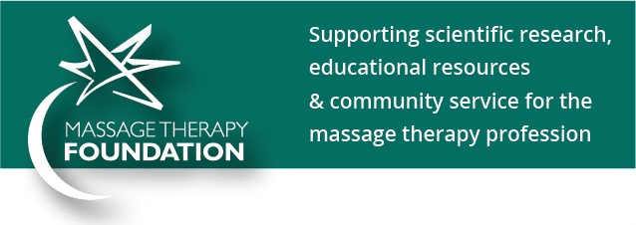
Massage Therapy Foundation Grants and Contests
Cut- and- paste to help us spread the word about our grant and contest opportunities!
Below you will find:
- One cut-and-paste image with grant deadlines
- Sample Facebook and Twitter posts for you to promote each grant/contest
Thank you for sharing!
Cut-and-paste image:

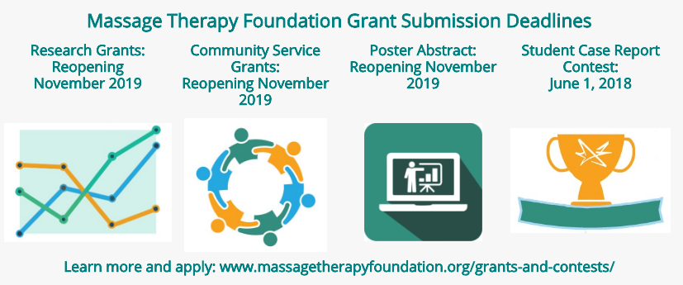Sample Facebook/Twitter posts:
Research Grant:
FB:
Research is critical for the advancement of the massage therapy profession. Do you represent a research organization that might benefit from Massage Therapy Foundation’s Research Grant program? http://bit.ly/2Fq4zO7

Twitter:
Massage Therapy researcher? Apply for a Research Grant from Massage Therapy Foundation! http://bit.ly/2Fq4zO7

Community Service Grant:
FB:
Massage Therapy Foundation Community Service Grants bring massage therapy to those who need it most but would otherwise lack access. Do you represent an organization that could benefit? Learn more here: http://bit.ly/2mnrBgI

Twitter:
Know a good cause in need of massage therapy? Apply for a Massage Therapy Foundation Community Service Grant! http://bit.ly/2mnrBgI

Poster Abstract Contest:
FB:
Do you have a research project you want to share with the profession? Massage Therapy Foundation poster sessions at the annual AMTA National Convention are right around the corner! Learn more about submitting an abstract: http://bit.ly/2t1GE5j

Twitter:
Research to share? Submit a poster abstract to Massage Therapy Foundation! http://bit.ly/2t1GE5j

Student Case Report Contest:
FB:
Are you a current massage therapy student? Massage Therapy Foundation’s Student Case Report Contest is now open! The submission deadline is June 1st: http://bit.ly/2E8aUkk

Twitter:
Student researcher? Massage Therapy Foundation’s Student Case Report Contest is now open! http://bit.ly/2E8aUkk

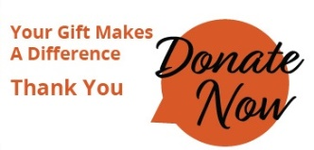

www.massagetherapyfoundation.org

