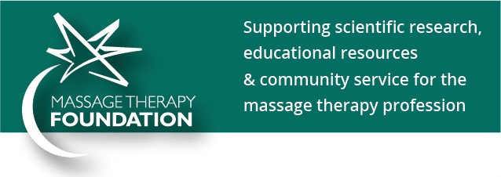
Massage Therapy Foundation – Ways to Donate
There are so many ways to make a difference at the Foundation - donate, volunteer, share, organize – help an organization that furthers the interests of the profession you love!
Donation Links:
Main donation page:
https://donatenow.networkforgood.org/1428681

Link to volunteer form:
http://massagetherapyfoundation.org/wp-content/uploads/Volunteer-application.pdf
Please email this form to:
Gini Ohlson, Executive Director
gohlson@massagetherapyfoundation.org

Donate Now: cut-and-paste image for use in promotional materials:

www.massagetherapyfoundation.org

