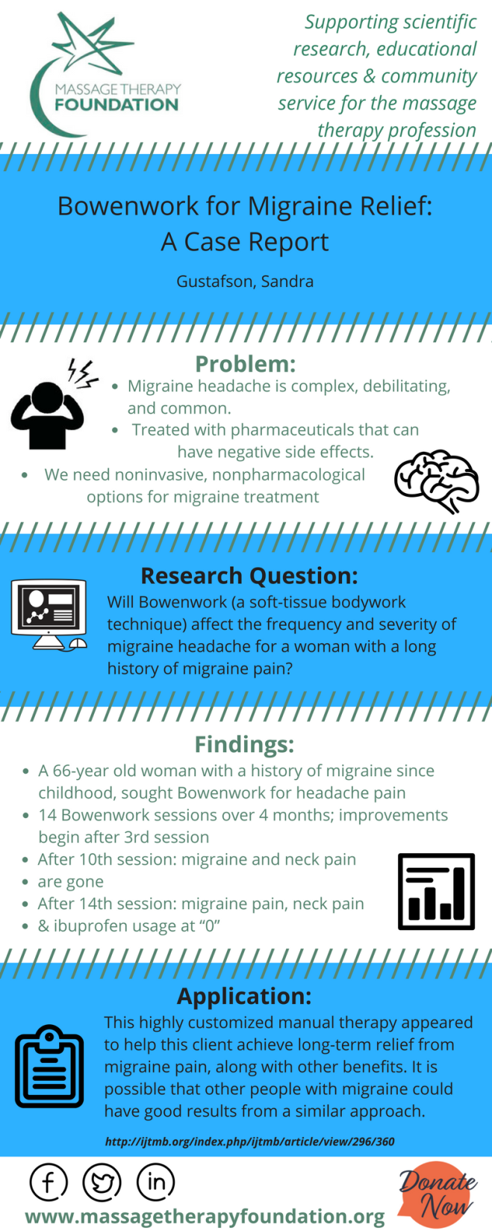
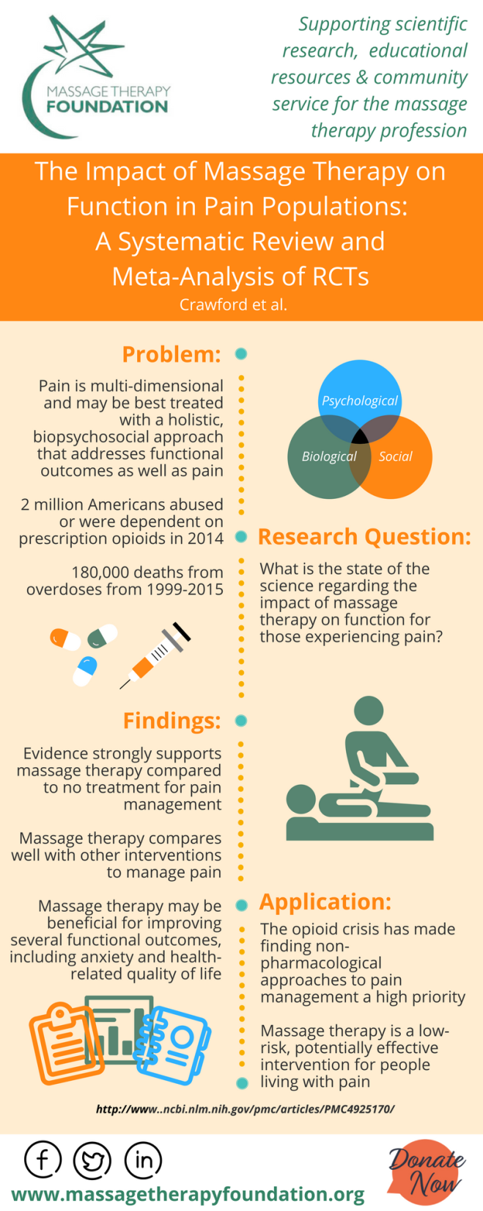

Please feel free to share these infographics with friends, colleagues, and clients. We thank you for your support! Download these and other newly released infographics at http://massagetherapyfoundation.org/research-infographics/

